Courtney Thurston

AP Art History

Mrs. Eckel

Early Christian and Byzantine Art Review

*Important points to include:*

* *Fully identify your selected image*
* *Include your reasons for selecting this image—key ideas*
* *Support your selection with specific examples that connect contextual and visual elements*

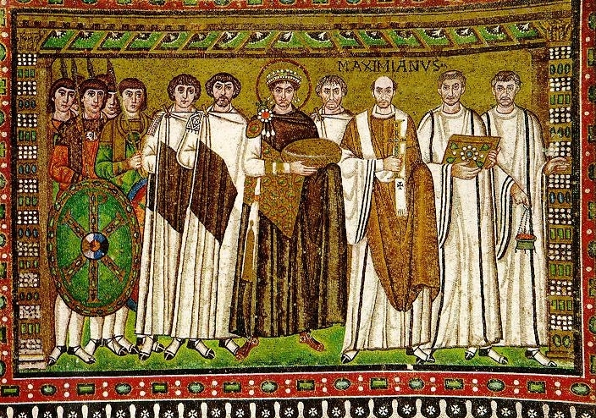

The work of art given above is a Justinian mosaic from the Byzantine Art period in Byzantium, circa 526 to 547 CE in San Vitale, Ravenna, Italy. The artwork is a mosaic and—like the mosaic I discussed in the previous lesson—was constructed with painstaking care for the Emperor. Unlike the previous mosaic we covered, which focused on the wife of Justinian I (Theodora), this mosaic focuses on Emperor Justinian I himself. The key idea here is again one of religiosity—the bread bowl in the center of the piece elects Justinian as the main focus of the mosaic, which is reinforced by his central position in the piece. The bread is an allusion to the leadership of Christ himself, the followers surrounding Justinian an allusion to the disciples.